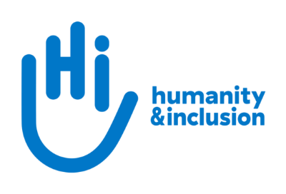

Application pack:

Media & Communications Officer

Do you want to improve the lives of people with disabilities and vulnerable people?

Humanity & Inclusion UK is looking for an enthusiastic and committed Media & Communications Officer to help raise the profile of our life-changing work. This is a varied role, building awareness in the UK of the challenges faced by people with disabilities and other vulnerable groups caught up in conflicts and disasters worldwide.

Securing quality media coverage and strengthening our brand recognition are central to our fundraising and communications strategy. Our communications focus on our core activities – disability inclusion, emergency response, physical rehabilitation and humanitarian mine action – underpinned by our values of humanity and inclusion.

If you are motivated to find new stories and create engaging content, bring a proactive, hands-on approach and enjoy juggling multiple priorities in a small team, we'd love you to join us. You'll work in an international environment, learn new skills, and play a real part in supporting people affected by crisis around the world.

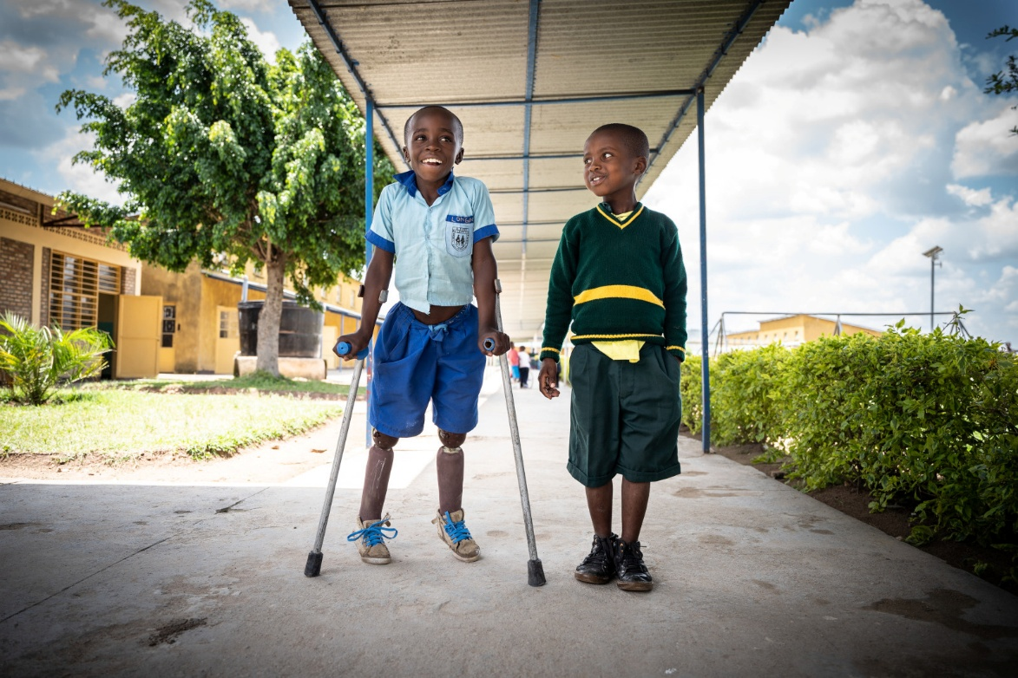
Photo: Longini (left) received prosthetic legs and support to go to school.
Rwanda © S. Wohlfahrt / HI

About Humanity & Inclusion

Humanity & Inclusion (HI) is an award-winning international charity working in situations of poverty and exclusion, conflict and disaster. We work tirelessly alongside disabled and vulnerable people to help meet their basic needs, improve their living conditions and promote respect for their dignity and fundamental rights.

Outraged by the injustice faced by people with disabilities and vulnerable populations, we aspire to a world of solidarity and inclusion, enriched by our differences, where everyone can live in dignity.

Since HI was founded in 1982, our work has benefitted tens of millions of people worldwide. In 2025, we ran 437 projects in 58 countries, directly supporting over 2.9 million people.

HI is a co-winner of the 1997 Nobel Peace Prize for our work towards banning and clearing anti-personnel landmines. We were also awarded the 2011 Hilton Humanitarian prize in recognition of our contribution to alleviating human suffering and supporting the most vulnerable people.

About Humanity & Inclusion UK (HI UK)

HI UK is a member of the HI Network, which is comprised of a Federation and eight national associations. As part of the Network, HI UK works towards a common strategy while maintaining its distinct identity as a UK charitable organisation. The HI Federation is responsible for implementing the Network’s social missions around the world. It operates under the names “Humanity & Inclusion” or “Handicap International”, depending on the country of operation.

Equal Opportunities Policy

HI UK is committed to diversity and inclusion. We recognise that discrimination shapes the opportunities that many people have in society and that people have different needs in order to realise their full potential.

Addressing this requires organisations to be proactive in creating environments that encourage the inclusion and development of all. Though we still have a long way to go, inclusion is central to our identity at HI UK and we are strongly committed to the continuous work that it requires.

We are particularly interested in hearing from candidates with disabilities and/or from Black and minority ethnic backgrounds, to help make us more representative. If you declare a disability and you meet the minimum requirements for the role, we will offer you an interview to demonstrate your skills. In the event that we receive a high level of applications for a role, we will invite those applicants who best meet the person specification.
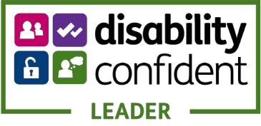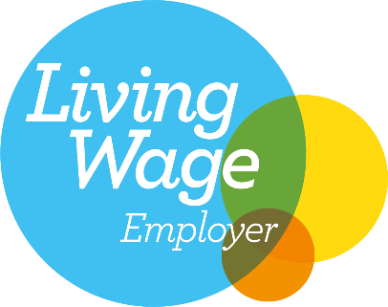

Employee Benefits

- All employees are entitled to 28 days’ holiday per year in addition to UK public holidays (pro rata for part-time employees). Colleagues may also take an additional day off for their birthday.
- Training and development opportunities are open to all staff and will be provided in order to support them to fulfil their roles.
- We value all our employees and strive to support them in their professional lives. This includes offering flexible-working opportunities, including home-working, flexible hours and two days’ volunteering leave each year.
- We offer a competitive workplace pension scheme, matching contributions up to 6% of gross salary.
- We are positive about employing persons with disabilities and are proud to be accredited as a Disability Confident Leader.
- We offer a Worklife Support Employee Assistance Programme, which provides confidential information, support and counselling.
- We strive to create a diverse and inclusive working environment, and we are constantly looking at ways to improve our policies, processes and culture.
- Our office is a short distance from Waterloo train station and Lambeth North underground station in London. There are also lots of bus stops nearby. We share an open space with other charities. The working environment is fairly quiet, with bookable meeting rooms, booths for individual meetings, noise-reduction pods and other informal meeting spaces. We have lifts, accessible toilets and a shared kitchen area. We are open to discuss any reasonable adjustments you might need.

Job Description

Job title: Media & Communications Officer
Organisation: Humanity & Inclusion UK (HI UK)
Salary: £36,808 per annum (Grade D)
Hours: Full time (35 hours per week)
Duration: 12-month fixed term contract with possibility for renewal. The applicant must have the right to live and work in the UK.
Location: Hybrid with minimum 6 days per month in our office in London (SE1).
Potential for international travel where required.
Department: Individual Giving and Communications (IGC)
Reporting to: Media & Communications Manager
Key linkages: HI UK Individual Giving, Major Giving and Institutional Relations teams.
HI Federation Communications team.

Background Information and Purpose of Post

Humanity & Inclusion is aiming for a step-change in our private fundraising and visibility in the UK. Securing quality media coverage and strengthening brand recognition are central to this. Our communications focus on HI’s core brand pillars – disability inclusion, emergency response, physical rehabilitation and humanitarian mine action – underpinned by our values of humanity and inclusion. Alongside working with journalists, we are building our media presence through partnerships and developing our in-house content production.

The main purpose of the post is to:
- Focus on the delivery of HI UK's media and communications strategy, supporting fundraising and brand awareness objectives.
- Secure high-quality coverage in target media through proactive story development, pitching and spokesperson support.
- Produce engaging digital and print content for UK audiences.
- Work collaboratively to support communications campaigns, partnerships and fundraising appeals.
- Monitor, analyse and report on media and communications impact.

Main Duties and Responsibilities

Media relations
- Work alongside the Media and Communications Manager to develop and deliver a targeted media and communications strategy that supports fundraising and brand awareness goals.
- Build and maintain relationships with UK and international journalists and producers.
- Proactively identify and pitch story and interview opportunities to secure coverage.
- Draft and distribute press releases, statements and reactive lines, including during breaking news and emergencies.
- Prepare and brief spokespeople for media opportunities and coordinate interviews.
- Facilitate media visits to overseas programmes in coordination with HI Federation and country offices and accompany journalists on visits where required.
- Contribute to applications and pitches for media fundraising appeals and partnerships.
- Work closely with communications colleagues across the HI Federation to amplify key messages and publications and adapt international content for UK media and audiences.

Content production
- Ensure that HI UK's website is well maintained and that static webpages are up to date.
- Regularly create and publish engaging news and stories on the website and social media channels.
- Develop in-house digital content (including blogs, photo stories, infographics and video) for UK audiences
- Lead on the design, layout and copy of HI UK's printed materials, using Adobe InDesign to produce professional, branded assets such as the annual report, banners and leaflets.
- Ensure that all communications reflect HI’s values and standards on consent, safeguarding, and ethical, inclusive storytelling.

Communications
- Actively contribute to HI UK's communications planning and editorial calendar.
- Work collaboratively across HI UK to increase consistency and quality of communications on HI's brand, activities and key campaigns.
- Coordinate with the private fundraising team to maximise HI UK’s brand impact and ensure that communications content strengthens supporter engagement.
- Develop media and communications activities to complement fundraising campaigns, particularly emergency appeals.
- Ensure consistent recognition of HI UK’s key funders and partners across communication channels and branded materials.
- Contribute to the roll-out of HI's global communications campaigns in the UK
- Support HI UK’s participation in public-facing campaigns with external coalitions and partners.

Other responsibilities
- Monitor and report on media coverage, comms campaigns and social media performance.
- Maintain a positive and collaborative working relationship with all colleagues and partners.
- Manage relationships with relevant suppliers and consultants.
- Represent the organisation at relevant external events and meetings.
- Keep up to date with, and adhere to, relevant legislation, regulatory procedures, innovation and best practice in the sector.
- Any other activities commensurate with the level of the post, as may be required.

Person Specification

We genuinely value diversity and are looking to build a team of people with a wide of range of personal and professional experience. If you don’t meet all of the criteria listed below but feel you would be a good candidate for this role, please apply. If you would like an informal conversation about this, please do send us an email or call us – we would love to hear from you.

Essential criteria

- Demonstrable experience in a media, communications and/or marketing role
- Proven track record of securing media coverage through proactive story development and outreach
- Excellent copywriting skills, with experience producing clear and engaging content for a range of audiences and channels
- Proven ability to create high-quality multimedia and print content using Adobe Creative Cloud or similar
- Experience managing website content through a CMS, including editing, publishing and maintaining webpages.
- Excellent written and verbal communication skills in English
- Excellent attention to detail
- Proficiency in Microsoft 365, website content management systems and digital communications tools
- Excellent administration and organisational skills
- Ability to prioritise competing demands and deliver high-quality work to tight deadlines
- Ability to work independently and collaboratively to achieve agreed objectives
- Ability to work effectively in an international and multicultural organisation
- Commitment to creating and maintaining an inclusive and protective environment for everyone that comes into contact with the organisation.

Desirable criteria

- Experience of working with external organisations and/or partners to deliver joint communications campaigns
- Knowledge of and passion for disability, humanitarian and development issues
- Experience working in a charity or an international environment
- French-language proficiency.

Conduct and safeguarding

Respect and dignity of all the people we support and come into contact with are at the heart of HI’s approach. All employees, volunteers (including trustees), partners, suppliers and consultants working with HI UK are expected to adhere to our Code of Conduct and related policies.

Our commitment to safeguarding means we seek to ensure that no harm comes to people as a result of contact with the organisation’s programmes, operations or people. This means ensuring the safety and protection of groups, including children and vulnerable adults, with whom the organisation is in contact, establishing safe and respectful workplaces that are free from harassment, abuse and discrimination, and maintaining HI’s reputation and high standards by preventing, addressing and learning from instances of wrongdoing.

This post is Safeguarding Level 1, which means no DBS check is required (unless the content of the post changes).

HI is a member of the inter-agency Misconduct Disclosure Scheme. In line with the principles of this scheme, when we contact referees, we request that they provide information in relation to any findings of sexual exploitation, sexual abuse and/or sexual harassment (‘misconduct’) during the candidate’s employment or any allegations of this kind that were under investigation at the point that the candidate left their organisation.

Application Process

To apply, please send your CV and a covering letter by email or post. Please also complete our Diversity monitoring form online.

By email: recruitment.uk@hi.org
By post: Humanity & Inclusion UK (Recruitment), Romero House, 55 Westminster Bridge Road, London SE1 7JB

If you disclose a disability during your application process and you are shortlisted for interview, we will contact you to discuss any reasonable adjustment you might need. However, if you have not disclosed, please note that all candidates invited for interview will be asked if any reasonable adjustments are needed. If you wish to disclose a disability please do so in your covering letter.

Closing date: 23:59 BST, Wednesday 19th August
Interviews are planned from Tuesday 1St September

For further information, please contact Humanity & Inclusion UK on 0870 774 3737 or by email at recruitment.uk@hi.org

